**What are CSS preprocessors?**

* Pre-processors extend CSS with variables, operators, interpolations, functions, mixins and many more other usable assets. SASS, LESS and Stylus are the most well known. Pre-processors, with their advanced features, helped to achieve writing reusable, maintainable and extensible codes in CSS. By using a pre-processor, you can easily increase your productivity, and decrease the amount of code you are writing in a project.

**Sass (Syntactically Awesome StyleSheets)**

Sass is an extension of CSS that adds power and elegance to the basic language. It allows you to use variables, nested rules, mixins, inline imports, and more, all with a fully CSS-compatible syntax. Sass helps keep large stylesheets well-organized, and get small stylesheets up and running quickly, particularly with the help of the Compass style library.

**Less**

* Less.js, (usually referred to simply as “Less”), is one of the most popular CSS preprocessors, and is probably currently the strongest competitor to Sass. Less extends CSS syntax thoroughly with mixins, variables, nested style rules, and even rule-set looping (which behaves similarly to for loops in a programming language).

**Stylus**

* Stylus is another one that’s been a strong competitor to Sass, and is a feature-rich extension of CSS. It has over 60 custom functions including saturation(), which lets you mathematically adjust the saturation of a CSS color.

**Features of SASS, LESS and Stylus:**

Variables**:**

* 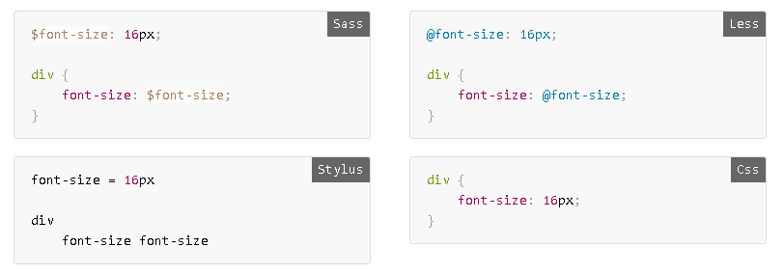Variables in SASS start with $ sign, in LESS @ sign and no prefix in Stylus. Both in SASS and LESS, values are assigned with colon (:), and with equals sign (=) in Stylus.

Nesting:

* Nesting provides a visual hierarchy as in the HTML and increases the readability.

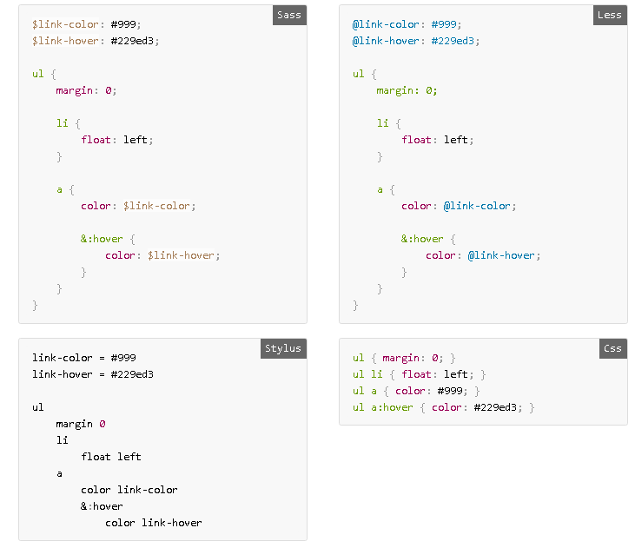

Mixins:

* Mixins are set of definitions that compiles according to some parameters or static rules. With them you can easily write cross-browser background gradients or CSS arrows etc.

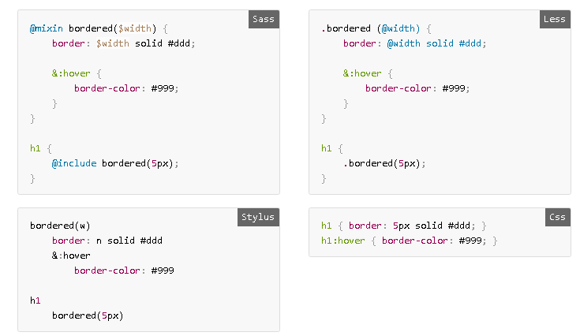

Extends:

* Extends are useful for sharing a generic definition with selectors rather than copying it in. All extended selectors are grouped in compiled CSS. SASS extends every instance of extended selector that includes its child selectors and inherited properties. However, in LESS you can select every instance of extended selector by adding "all" attribute to extend method or you can select only the main instance.

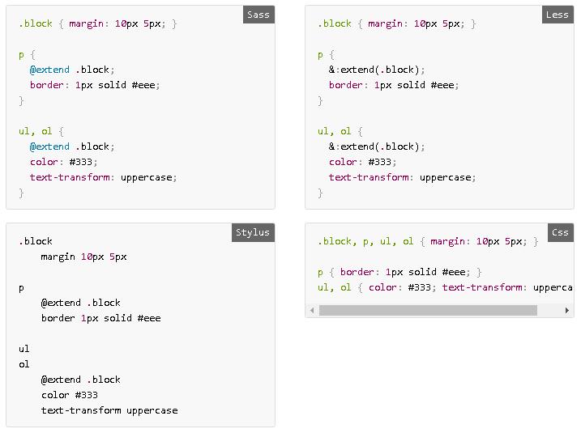

Color Operations:

* All three pre-processors have color functions to play with colors.

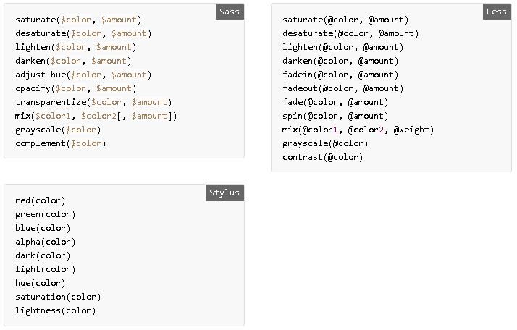

If/Else Statements:

* Control directives and expressions help to build similar style definitions according to matched conditions or variables. SASS and Stylus support normal if/else conditionals. But in LESS, you can achieve this with CSS Guards.

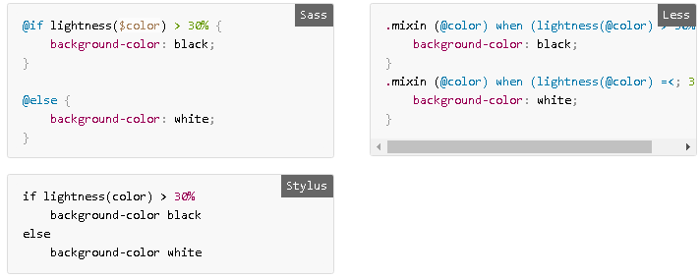

Loops:

* Loops are useful when iterating through an array or creating a series of styles as in grid widths. LESS is using CSS Guards and recursive mixins for looping.

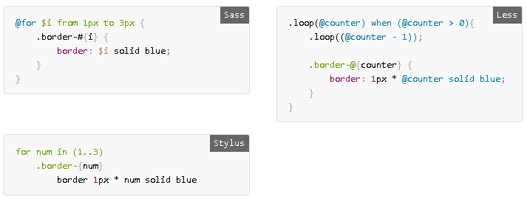

Math:

* Math operations can be used for standard arithmetic or unit conversions. SASS and Stylus support arithmetic between different units. In addition to simple math, pre-processors also have complex math support such as ceiling, rounding, getting min or max value in a list etc.

